**Leave Request Mobile Application**

Leave Request Mobile Application is designed for approver to do actions for a leave request. Each action is an operation in webservice that corresponds to a service in BPM.

In BPM, we have a web service named “IHMWebservice” including 3 operations:

* “checkExistingManager” is used in Login page for validation to check if there is any user in “Manager” team. It is “Check Existing Manager” service in BPM.
* “getAllActiveTasks” is used in Leave Request Approver page to get active tasks for current’s user. It is “Get All Active Tasks By User” service in BPM.
* “completeTask” is used in Leave Request Approver page to complete a task of an instance and to approve or reject a leave request. It is “Complete Task By Id” service in BPM.

1. Login page

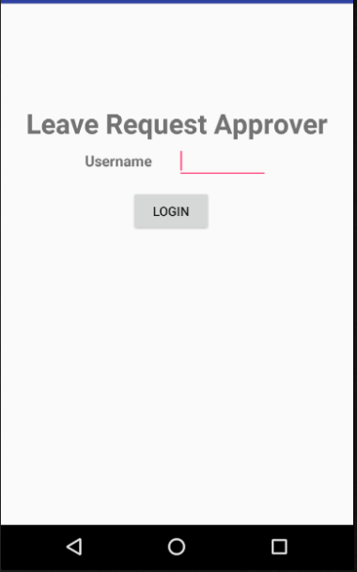

To log in, we input username and BPM will check if there is any user in “Manager” team.

If there is no user exists, an alert is displayed:

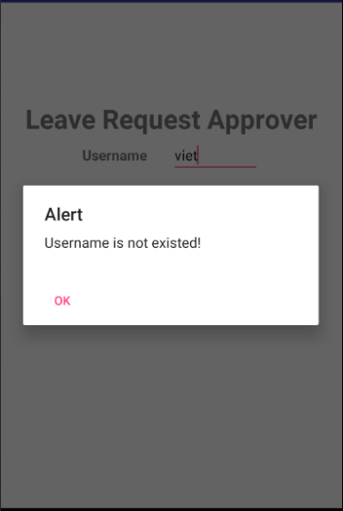

Otherwise, the page is moved to Leave Request Approver page.

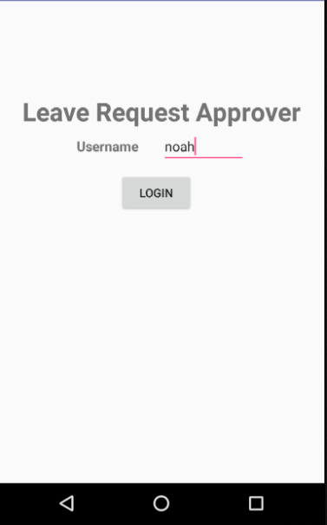

1. Leave Request Approver page
   1. Leave Request Details

In this page, we will show Leave Request Detail:

* + Subject
  + Owner
  + Requester
  + Start date
  + End date
  + Leave Type
  + Description

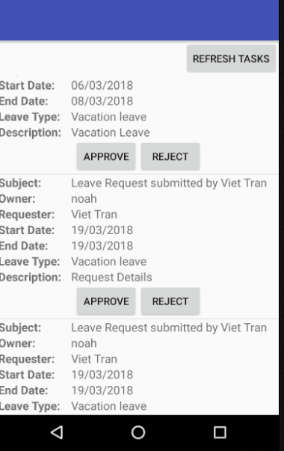

“Refresh tasks” button is to reload page.

“Approve” button is to complete a task and approve a leave request.

“Reject” button is to complete a task and reject a leave request.

* 1. Reject Request

When “Reject” button is clicked, the system executes 2 actions:

* + Update leave request data in Database
  + Complete the task in process

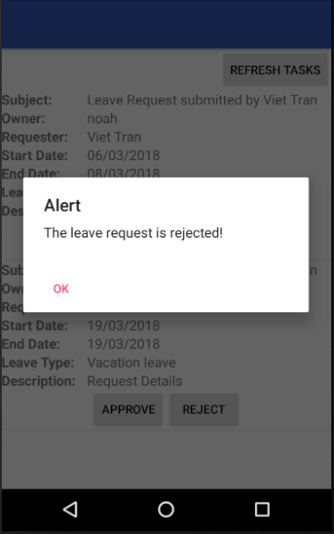

In process, the task is completed and is moved back to requester.

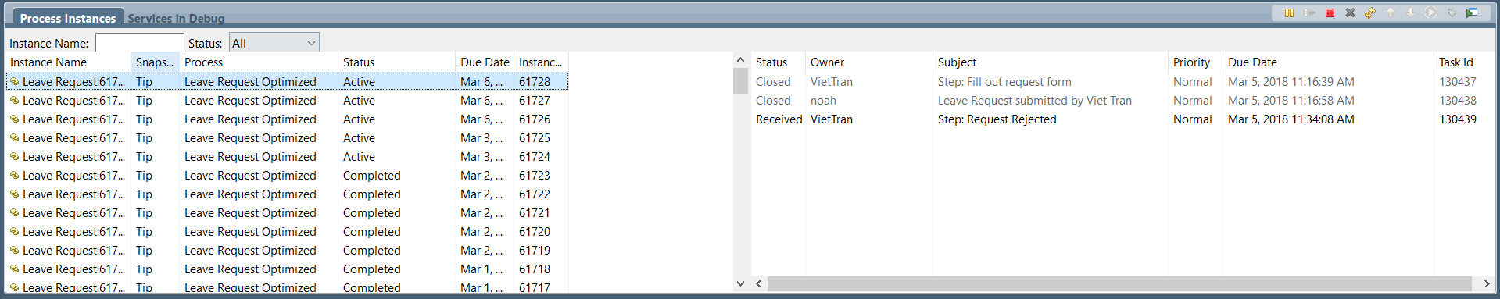

* 1. Approve Request

When “Approve” button is clicked, the system executes 3 actions:

* + Verify if the leave request is existed
  + Update leave request data in Database
  + Complete the task in process

If there is a leave request is existing, an alert will show:

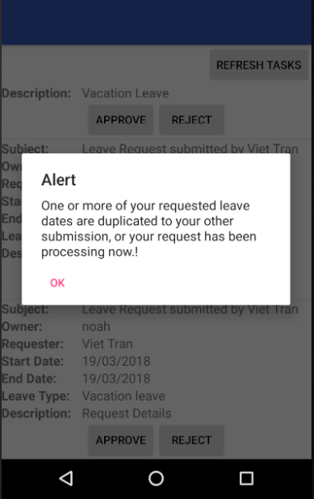

Otherwise, the leave request is approved.

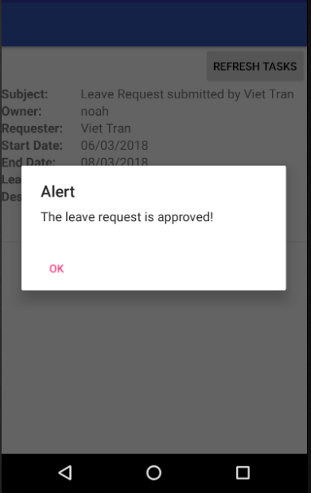

In process, the task is completed and is moved to next approver.

